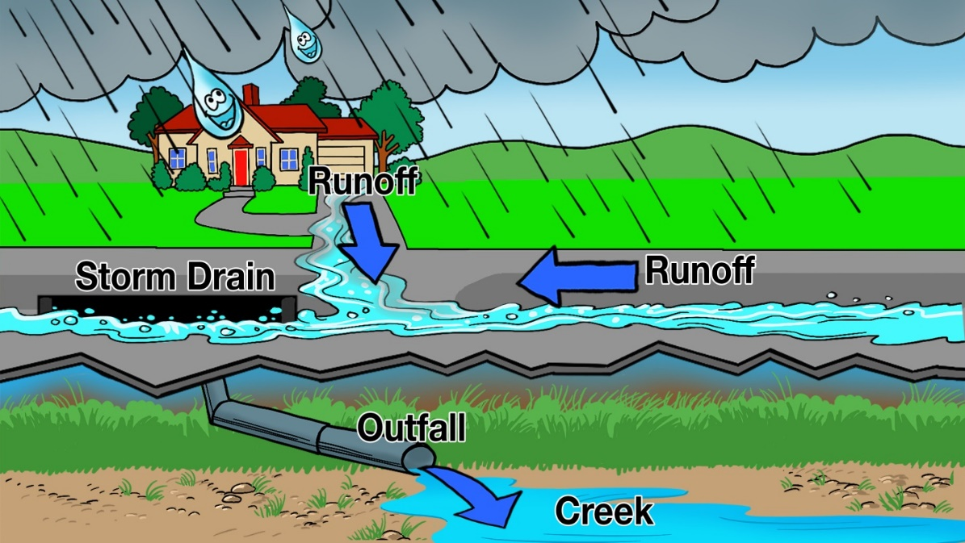
1. Where can you find a storm drain like the one in the picture?

2. Explain what is happening in this picture.

3. Only rain down the storm drain! Why should only rain go down the storm drain?

